Q.N.1) Create a class of a Human Being. Define its possible properties and methods using appropriate access modifiers. Access the class members using the object.

Ans.

class HumanBeing

{

private String name;

private String food;

private String language;

public void eat ()

{

System.out.println (name + " Eats " + food);

}

public void speak ()

{

System.out.println (name + " Speaks " + language);

}

public void run ()

{

System.out.println (name + " is Running");

}

public static void main (String[]args)

{

HumanBeing Pritam = new HumanBeing ();

Pritam.initObj("Pritam","Rice","English");

Pritam.eat ();

Pritam.speak();

Pritam.run();

}

private void initObj(String n,String f,String l)

{

name=n;

food=f;

language=l;

}

}  **OUTPUT**

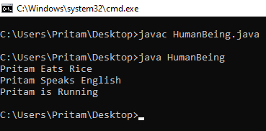

Q.N.2) Create a class of a Vehicle. Define its possible properties and methods using appropriate access modifiers. Access the class members using the object.

Ans.

public class vehicle {

String color;

String brand;

int model;

String speed;

public void initObj(String c, String b, int m, String s) {

color = c;

brand = b;

model = m;

speed = s;

}

public void display() {

System.out.println("the color is "+color+"\nthe brand is "+brand+"\nthe model is "+model);

}

public void run() {

System.out.println("Top Speed is "+speed);

}

public static void main(String[] args) {

vehicle car = new vehicle();

car.initObj("red", "ferari", 812, "340 kmph");

car.display();

car.run();

}

} **OUTPUT**

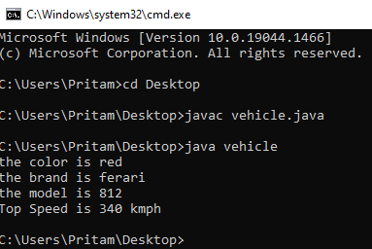

Q.N.3) Create a class of a Bird. Define its possible properties and methods using appropriate access modifiers. Access the class members using the object.

Ans.

public class bird {

String name;

String feathers;

String wings;

public void fly(String name) {

System.out.println(name + " can fly !!");

}

public void lay_eggs(String name) {

System.out.println("Birds lay eggs !!");

}

public static void main(String[] args) {

bird parrot = new bird();

parrot.name = "PARROT";

parrot.feathers="green";

System.out.println("Name is "+parrot.name);

System.out.println("Feathers are "+parrot.feathers);

parrot.fly(parrot.name);

parrot.lay_eggs(parrot.name);

bird sparrow = new bird();

sparrow.name = "SPARROW";

sparrow.feathers="brown";

System.out.println("Name is "+sparrow.name);

System.out.println("Feathers are "+sparrow.feathers);

sparrow.fly(sparrow.name);

sparrow.lay_eggs(sparrow.name);

}

}

**OUTPUT**

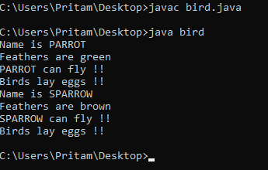

Q.N.4) Create a class of  a Computer.  Define its possible properties and methods using appropriate access modifiers. Access the class members using the object.

Ans.

public class computer {

private String color;

private String generation;

private String name;

private String storage;

private String processor;

private String ram;

public void show() {

System.out.println("Brand Name is "+name);

}

public static void main(String[] args) {

computer a = new computer();

a.initObj("Black","7th","1TB","Intel","4GB");

a.name = "Dell";

a.show();

a.display();

}

public void initObj(String c, String g,String s, String p, String r) {

color = c;

generation = g;

storage = s;

processor = p;

ram = r;

}

public void display() {

System.out.println("The color is "+color );

System.out.println("Generation is "+generation);

System.out.println("Storage is "+storage );

System.out.println("processor is "+processor );

System.out.println("Ram is "+ram );

}

}  **OUTPUT**

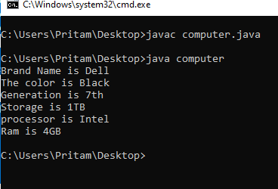

Q.N.5) Create a class called "MyDateTime", which has properties day,month,year,hour,minute and second. Create the parameterized constructor to initialize date and write get-set method for all parameters ,and write functions  getDate(), setDate(), printDate().

Ans.

**public** **class** MyDateTime {

**private** String date;

**private** String time;

**private** String day;

**private** String month;

**private** String year;

**private** String hour;

**private** String minute;

**private** String second;

**public** MyDateTime(String day,String Month,String year, String hour, String minute, String second) {

**this**.day=day;

**this**.month=Month;

**this**.year=year;

**this**.hour=hour;

**this**.minute=minute;

**this**.second=second;

}

//setter

**public** **void** setDate() {

**this**.date=day+"/" + month +"/"+ year;

}

**public** **void** setTime() {

**this**.time=hour+"-" + minute +"-"+ second;

}

**public** String getTime() {

**return** time;

}

//getter

**public** String getDate() {

**return** date;

}

}

**public** **class** AnotherClass {

**public** **static** **void** main(String[] args) {

MyDateTime mydate= **new** MyDateTime("29","01","2022","6","30","15");

mydate.setDate();

mydate.setTime();

System.***out***.println("The Time is "+mydate.getTime());

System.***out***.println("The Date is "+mydate.getDate());

}

}

**OUTPUT**

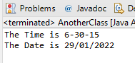

Q.N.6 Create a class “MyString” class. Define its properties and write following methods in it. Please do not use library functions for this operation.

* 1. string concat
  2. string append
  3. string replace
  4. Length of string
  5. Find a Character from string

Ans. **import** java.util.Scanner;

**public** **class** MyString {

**public** **static** **void** main(String[] args) {

//String concat

String a;

String b;

Scanner sc = **new** Scanner(System.***in***);

System.***out***.println("Enter first string=");

a=sc.nextLine();

System.***out***.println("Enter second string=");

b=sc.nextLine();

System.***out***.println("The Concatineted String is=");

System.***out***.println(a+b);

} **OUTPUT**

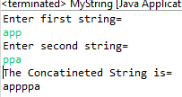

Ans.

**class** MyString{

**private** String str=" ";

**public** String append(String str) {

**this**.str=**this**.str+str;

**return** **this**.str;

}

**public** **static** **void** main(String[] args) {

MyString obj= **new** MyString();

obj.append("apple");

obj.append(" Ball");

System.***out***.println(obj.str);

obj.append(" cat");

System.***out***.println(obj.str);

}}

**OUTPUT**

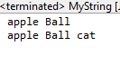

**Ans.**

**class** MyString{

**public** **static** **void** main(String[] args) {

String str = "My Name is Pritam";

System.***out***.println("String: "+str);

// replacing character at position 8

**int** pos = 8;

**char** rep = 'p';

String res = str.substring(0, pos) + rep + str.substring(pos + 1);

System.***out***.println("String after replacing a character: "+res);

}

} **OUTPUT**

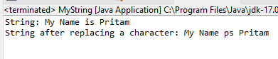

**Ans.**

**import** java.util.*;

**class** MyString{

**public** **static** **void** main(String args[]) {

**int** i=0;

String str;

Scanner sc = **new** Scanner(System.***in***);

System.***out***.println("Enter the string");

str=sc.nextLine();

**char** ch[] = str.toCharArray();

**for**(**char** c : ch)

{

i++;

}

System.***out***.println("Length of the string = "+i);

}

} **OUTPUT**

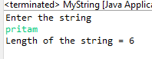

Ans.

**import** java.util.*;

**class** MyString{

**public** **static** **void** main(String args[]) {

**int** i,count=0;

Scanner sc=**new** Scanner(System.***in***);

System.***out***.println("Enter a character to find= ");

**char** c = sc.next().charAt(0);

String str="apple";

**char**[] ch=str.toCharArray();

System.***out***.println(Arrays.*toString*(ch));

**for**(i=0;i<ch.length;i++) {

**if**(c == ch[i]) {

count++;

**break**;

}

}

**if**(count==1) {

System.***out***.println("Character found in string at position "+i);

}

**else** {

System.***out***.println("Character not found");

}

}

} **OUTPUT**

